Project Design Phase-II CUSTOMER JOURNEY MAP

|  |  |
| --- | --- |
| Date | 18 October 2022 |
| Team ID | PNT2022TMID28524 |
| Project Name | Natural Disaster Intensity Analysis and Classification Using Artificial Intelligence |
| Maximum Marks | 4 Marks |

**CUSTOMER JOURNEY MAP**

STEP 1: **ENTICE**

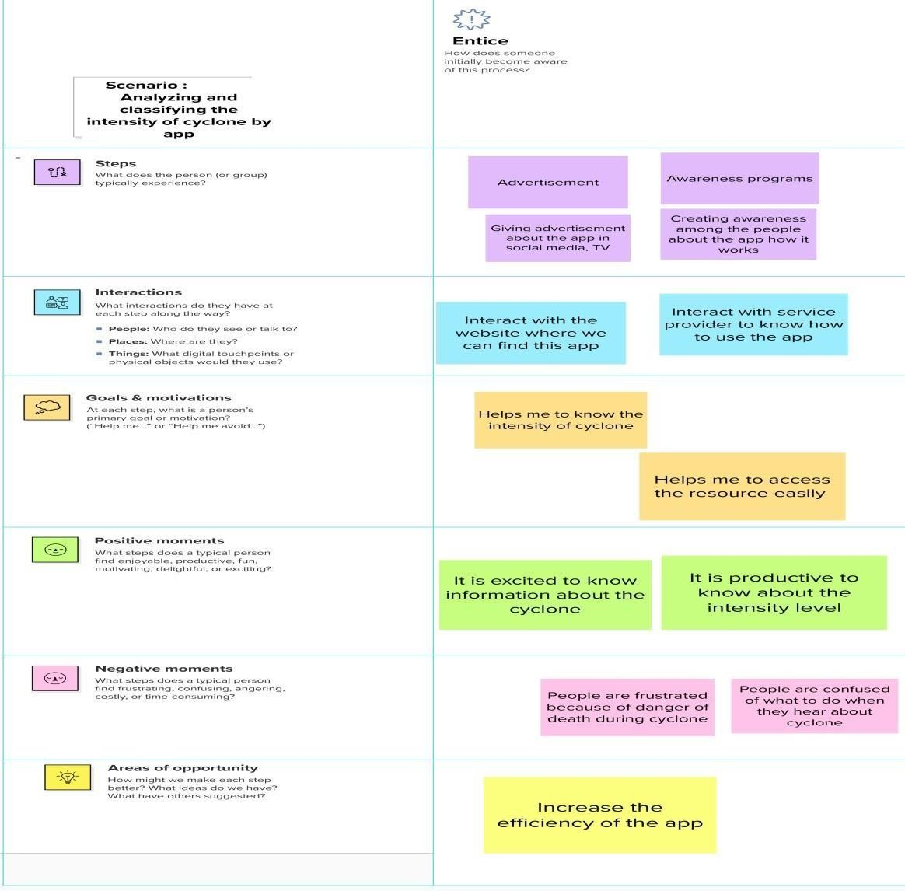

STEP 2 : **ENTER**

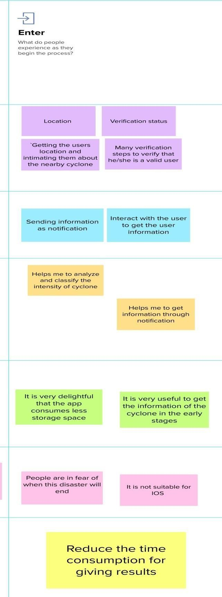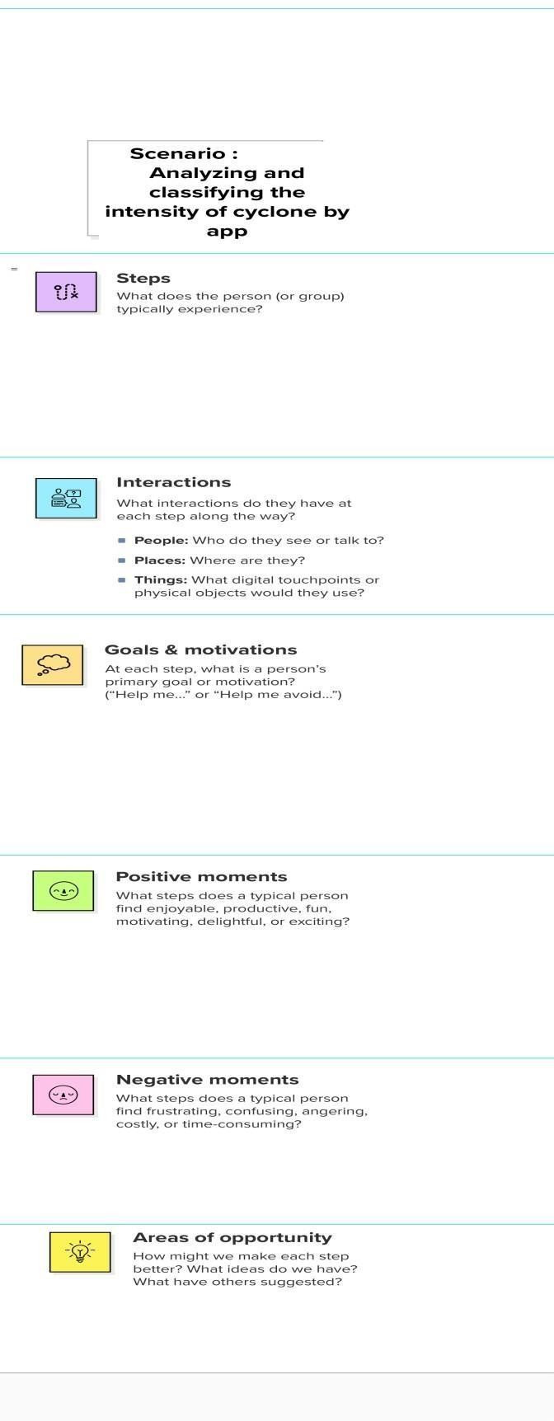

STEP 3 : **ENGAGE**

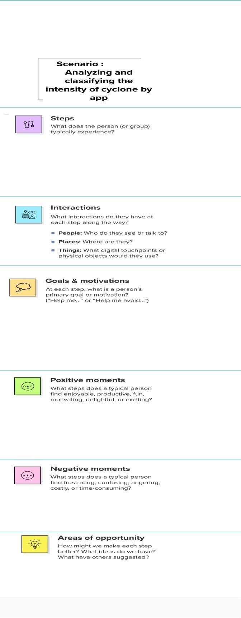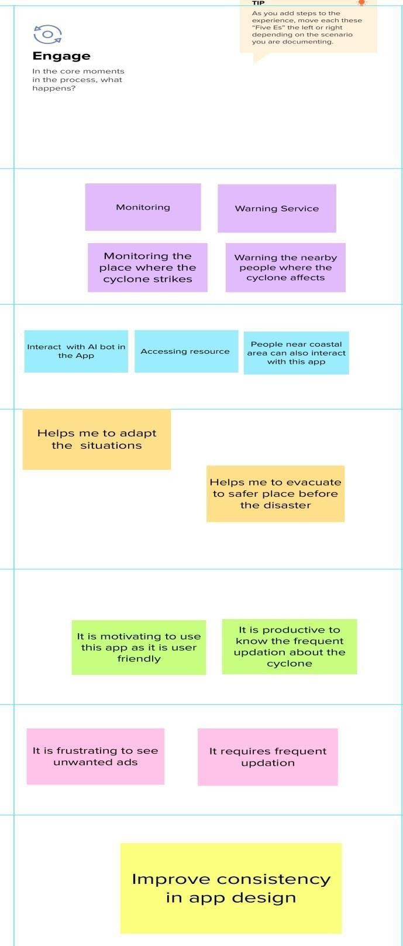

STEP 4 : **EXIT**

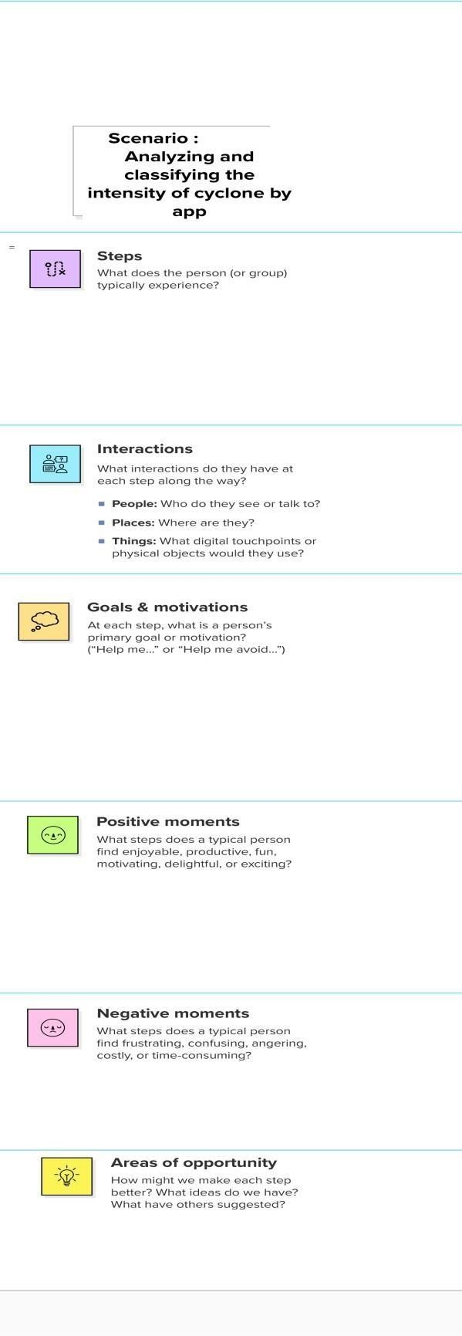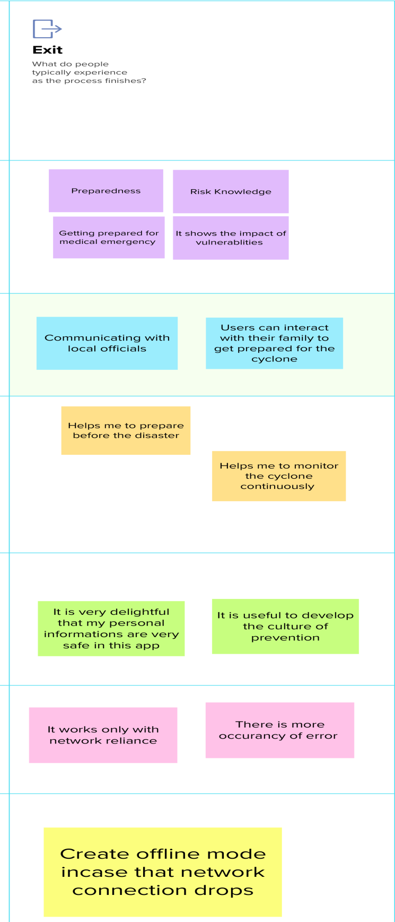

STEP 5 : **EXTEND**

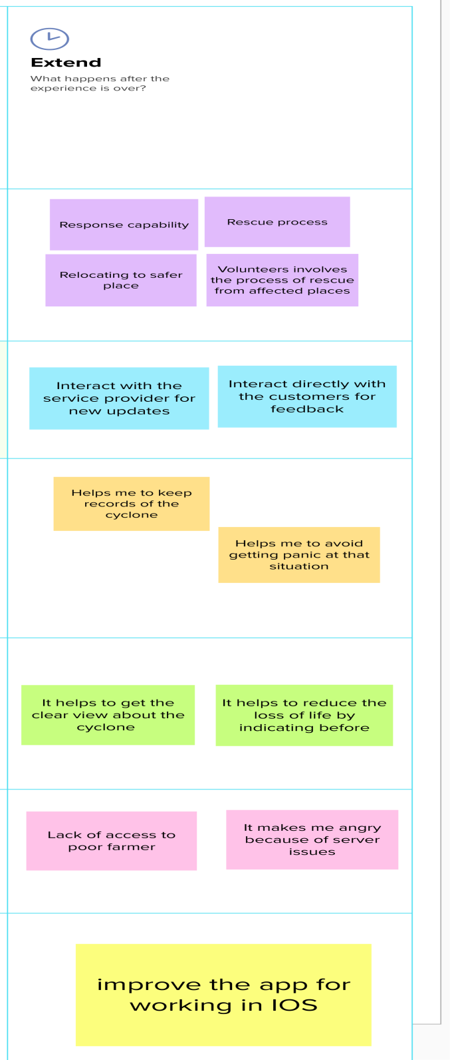

**CUSTOMER JOURNEY MAP**

